|  |
| --- |
| NEELADHRI CERAMICS |
| Changes required in the website and Content |
| Aniruddha Setty |

Introduction Page

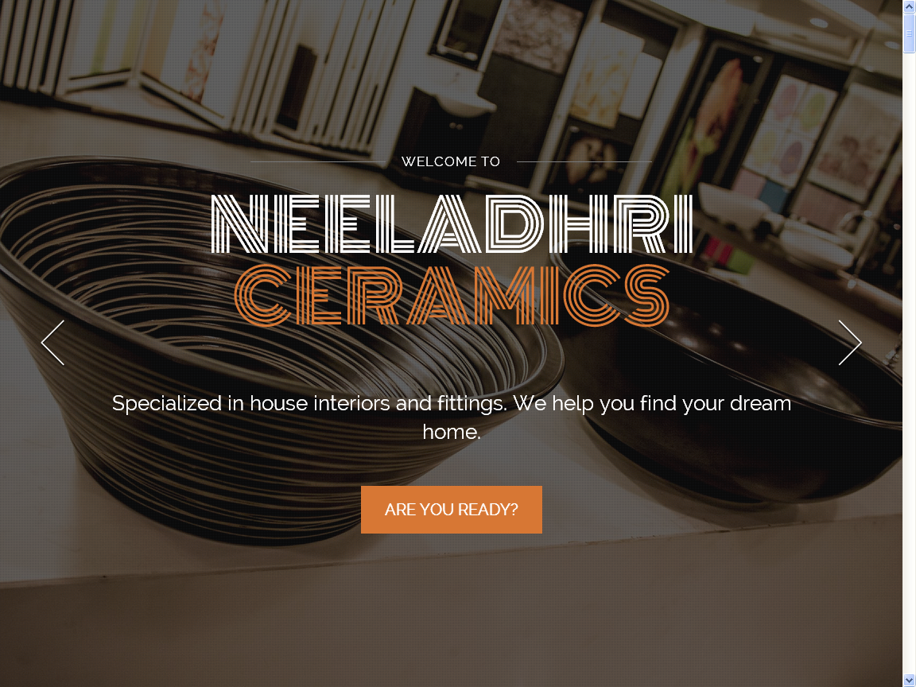

* 3 additional images need to be added for the back ground.
* When clicked on Discover the page has to scroll up to the exact next page which is ABOUT US page.
* Wordings instead of ‘specialized in house interiors and fittings. We help you find your dream home.’ It has to be **“Specialized in providing a broad spectrum of integrated solutions for the best in home beautification accessories for a perfect dream home.”**
* Animation provided to the NEELADHRI CERAMICS is not that convincing.

.

About Us

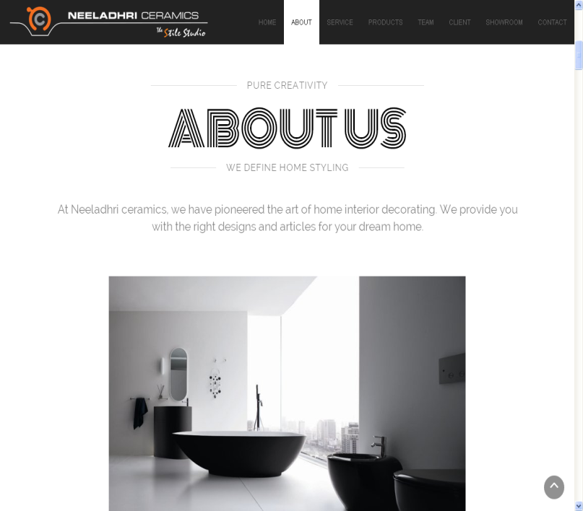 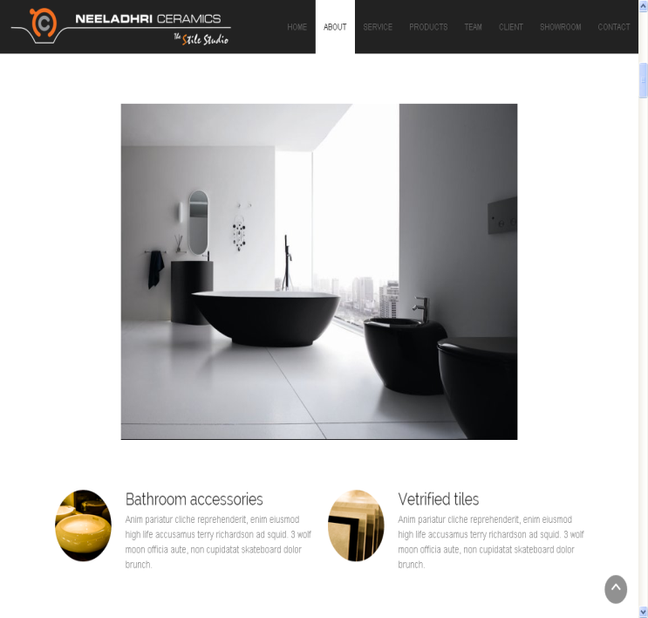

* Increase the gap between About and Us
* Wordings could be “NEELADHRI CERAMICS has established a reputation for itself as a supplier of quality products, both functional and attractive since its inception.”
* Additional three or four images could be provided and dramatic change of image is suggested
* Instead of 2 tabs below the image, 4 tabs are required naming:
  + Tiles
    - Description: Wall tiles; Floor tiles; Glass Bricks; Interior and exterior cladding; Murals; Vitrified tiles; Wooden Flooring; Exterior floor tiles etc..
  + Bathrooms
    - Description: Taps; Sanitary ware; Wellness; Wash Bowls; Vanities; Geysers; Mirrors; Shower Systems
  + Kitchens
    - Description: Sinks; Hobs and Chimneys
  + Allied Accessories
    - Description: Tile Grouts; Tile Adhesives; Floor Grates; Pressure Pumps; Accessories

(Please ensure that the 4 tabs are in the same order as mentioned)

* Click on these 4 tabs should redirect to a different page or open like a page extension showing main tabs and few images for say about 6 in each tab. Visitor should feel like opening a gallery.
* Descriptions mentioned are optional. If you find any better description please do go ahead with your thoughts.

About Us 2

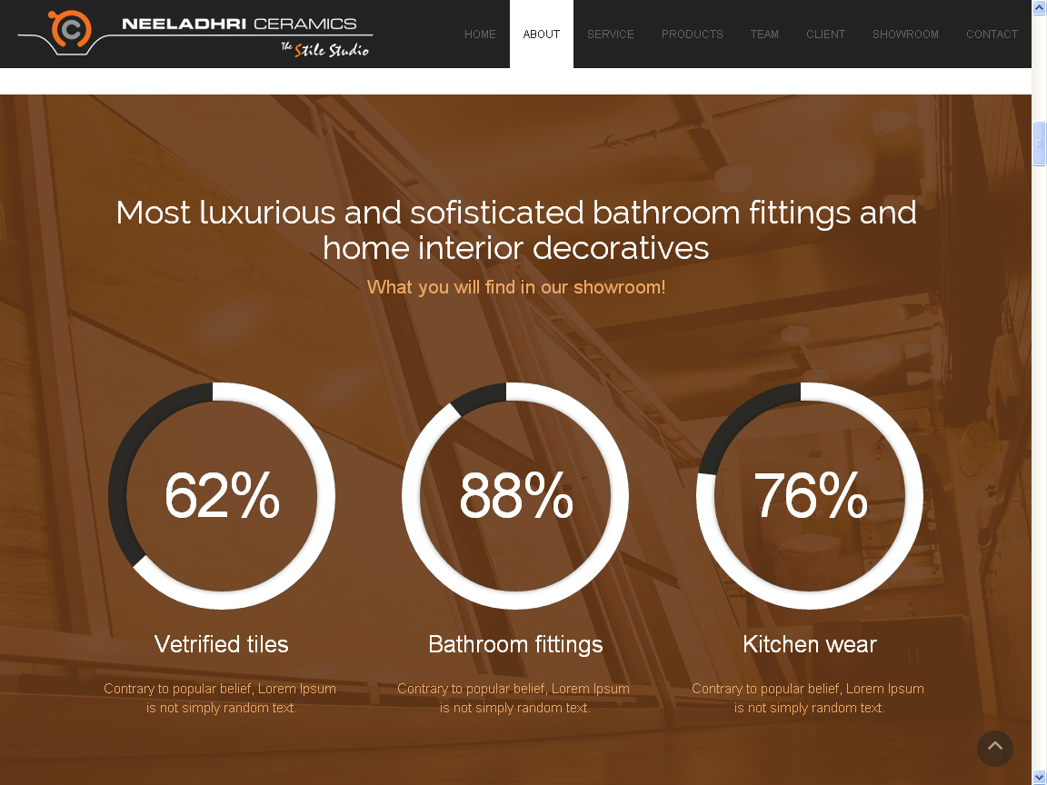

* Tiles 88%
* Sanitaryware 76%
* Faucets 62%
* In the two lines below each section mention the description on what basis these figures are. (Sorry! I forgot what you exactly told me the other day) add a disclaimer in the last making it almost visible.

Our Services

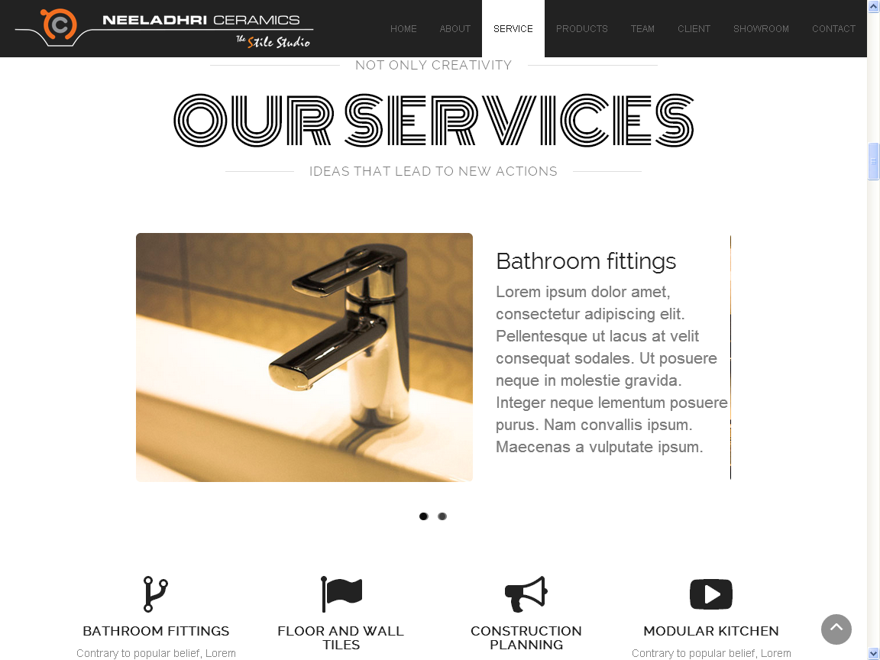

* The showroom provides a unique retail experience for customers with ample parking facility wherein, we combine the outstanding product lines with commitment to customer delight. Staff here will guide, educate and inspire you throughout the selection process.
* We offer value for money products to our valuable customers. You can avail our service from well experienced sales personnel at any time regarding our products and services.
* We assure the best package of virtual colours and designs, and it will help you in providing a broad spectrum of integrated solutions for a perfect dream home.
* Bottom tabs: Instead of construction planning: Bathroom Planning; Instead of Modular Kitchen: Kitchen Solutions; Instead of Bathroom Fittings: Allied Accessories

Our Services 2

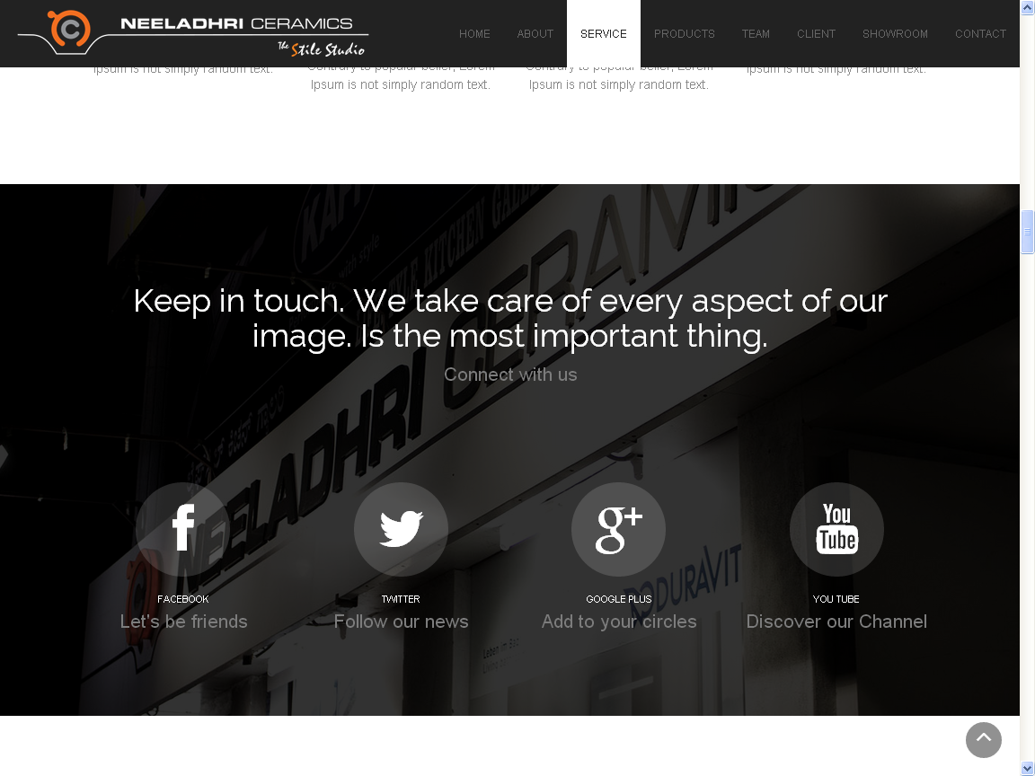

* I feel the line “Keep in touch.” There is a sentence formation error, not so appealing. Please correct that.
* Finding the animation response to be slightly lagging.
* Bathroom planning; Kitchen solutions and Allied products should be highlighted in Our Services 1

Products

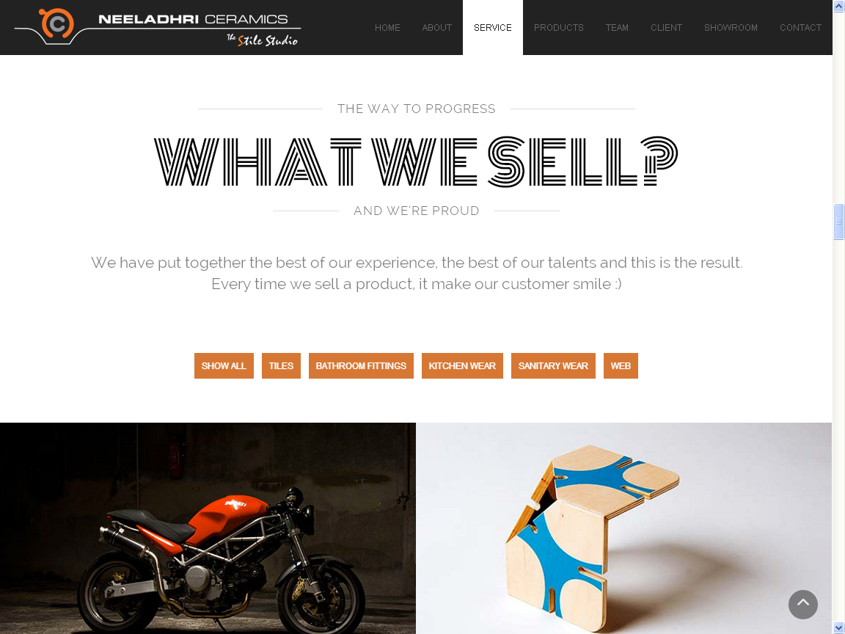

* This page is about Products but is showing as SERVICES correct that.
* Correction “it MAKES our customer smile”
* Add a smiley instead of ‘**:)**’ (make sure its big bright and happy)
* Images provided as a gallery should be changed.
* Tabs provided should be categorized as Bathrooms; Bedrooms; Home Theater; Suites; Kitchens; Laundry Rooms; Living Rooms; Outdoor; Splash Backs
* Each category should have about 15-20 images (please download images suitable from Internet and make sure that the images are quite unique)
* When the user clicks on the category or image it should not open a new page.

Our Team

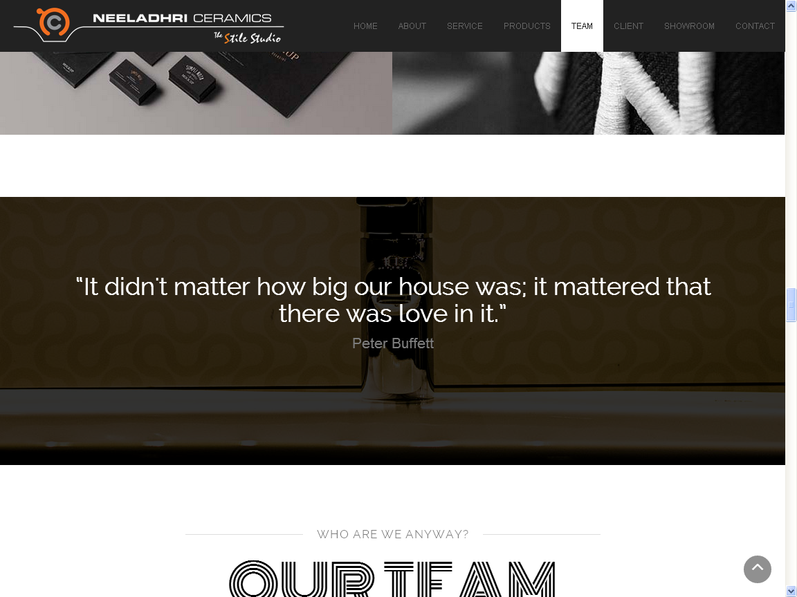

* This page seems to be just fine.
* Background needs to be little brighter
* Name needs to be more legible

Our Team 2

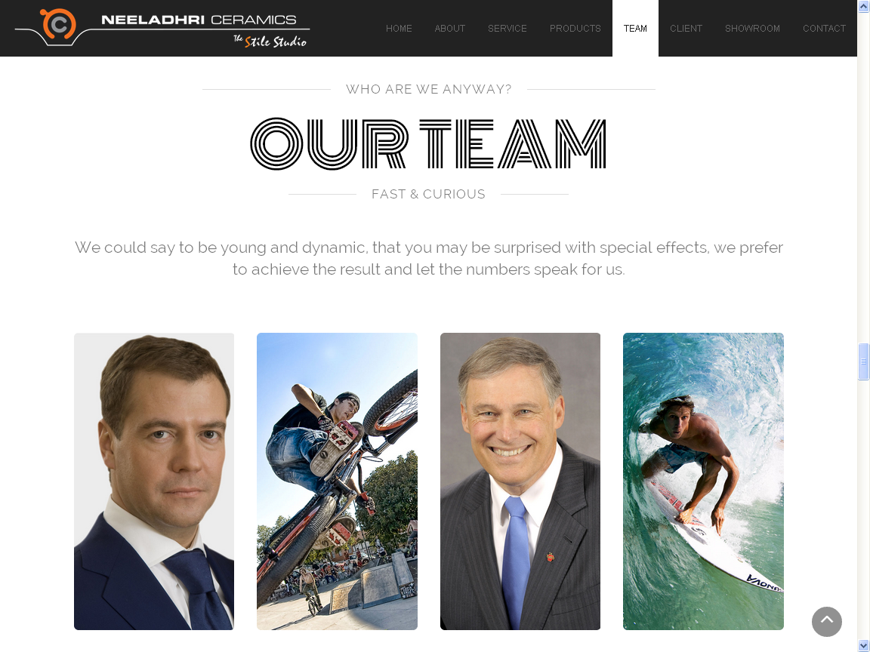

* Mr. Badrinath C R (Mr. Badrinath doubles up as the founder and managing partner of the firm, when it comes to being prolific, it doesn't get much bigger than him, he can make magic out of an empty window sill, because that’s how he sees life: in magical, beautiful, ever-transforming frames.)
* Ms. Triveni Badrinath (She is widely recognized for her role in shaping the firm as well as her contributions to various activities in the firm. She maybe a biggest critic but she's also the spark that set it all in motion and has been part of the family, every step of the way.)
* Mr. Aniruddha C B (This thin, tall, weirdly innovative, oddly magical boy who is passionate about what he does, pours heart and soul into everything he decides to do. There is no midway for him- not in cooking a six course meal, not in life, certainly not in his work.)
* Ms. Vidheesha Kasthoori (Like her name, which stands for all that is beautiful, mystical and divine in the daily working of Neeladhri Ceramics. With an impish smile and a general tendency to brighten our day and add energy to our life. So if we know anything of how to celebrate love, life, and the goodness of human spirit, this is where it comes from.)

Our Client

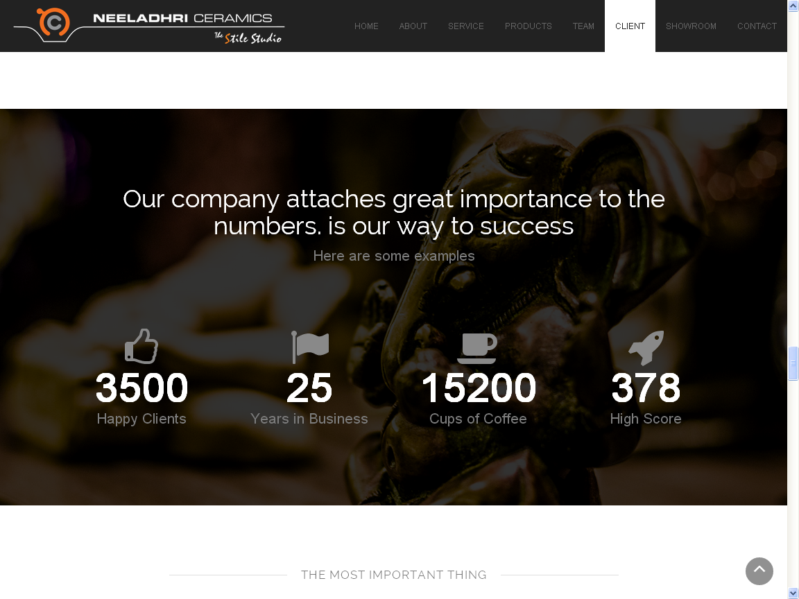

* Happy Clients 38000 +
* Years in Business 10
* Cups of Coffee 65385 +
* High score is left to you. I actually forgot what we thought of putting in there :P

Our Clients 2

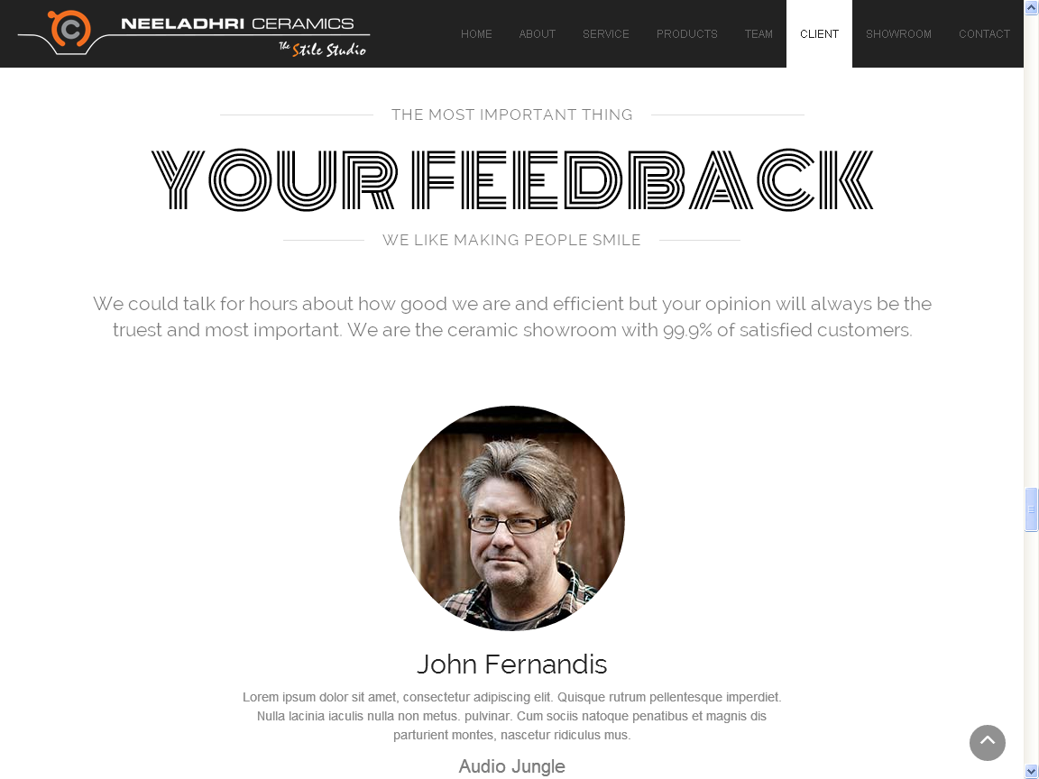

* We are the ceramic showroom with 99% of satisfied customers.
* Our Customers are from all walks of life, and the demand has always been to provide a variety of appealing options. From Hoteliers to Builders and Architects, they all cherish the wide options and service they get at NEELADHRI CERAMICS. We have some of the prominent clients shopping with us regularly for the best in home beautification accessories. (If possible try conveying this message too.)
* The images and feedback might take a little longer as we are yet to collect the feedback.
* For this section I might require another week’s time (Sorry for the delay!)

Our Showroom

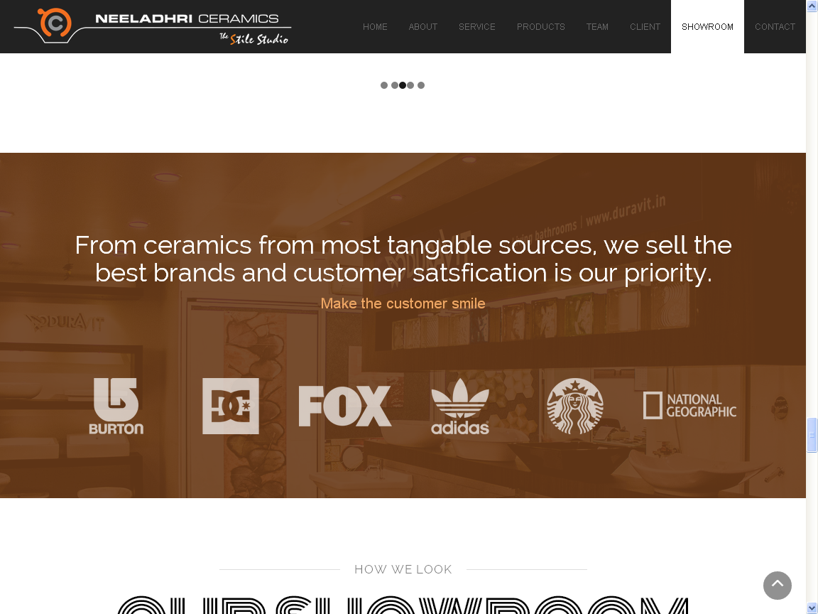

* The brands that we deal with are:
  + Cera
  + Duravit
  + Jaquar
  + Somany
  + Schablona
  + Carysil
  + Faber
  + Tocco
  + Magickwood
  + Farriti

Our Showroom 2

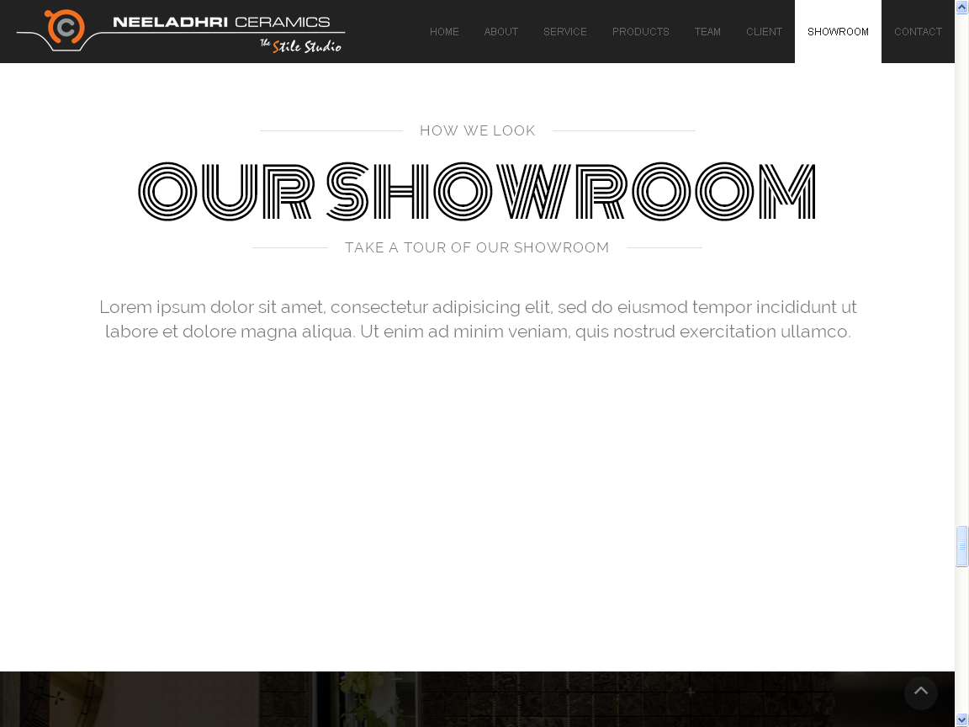

* Walkthrough of the showroom needs to be added here.

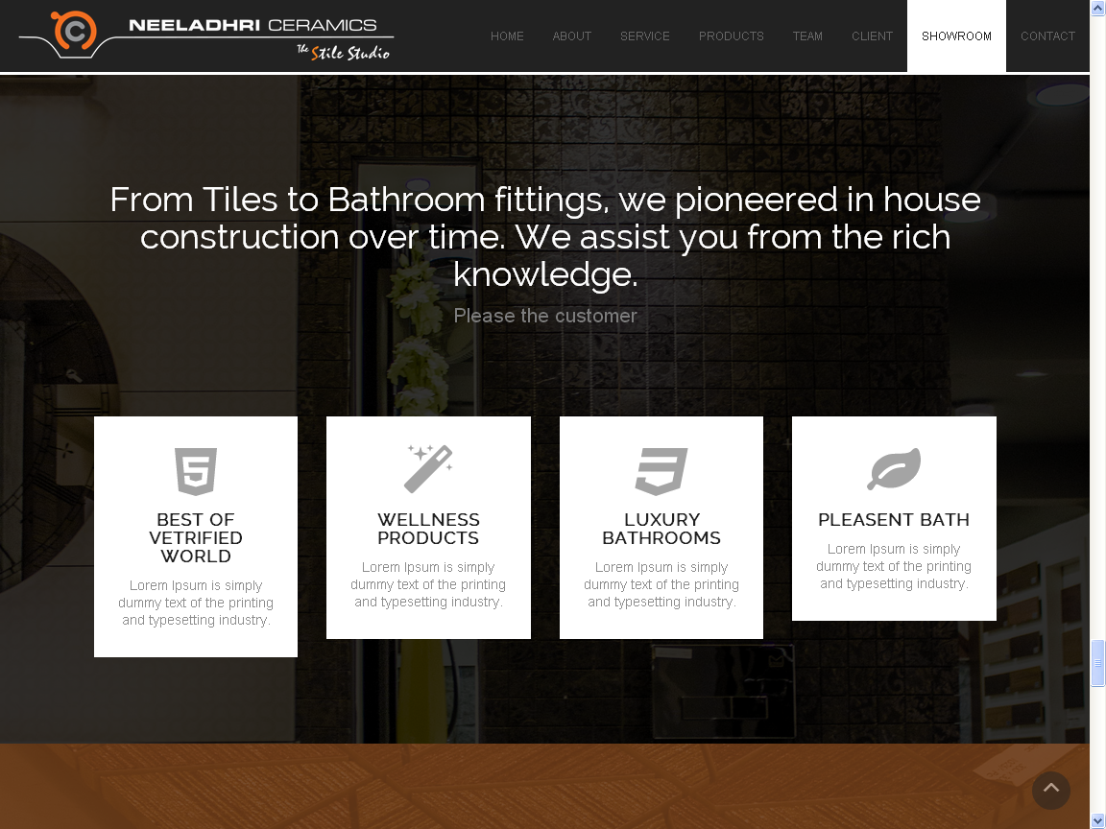

* The state-of-the-art showroom offers you an opportunity to create your very own dream bathroom with a wide range of Sanitary wares, Tiles for wall and floor, Bath Fittings, Whirlpools, Bath Systems, Hobs and Chimneys, Multifunction Systems and Bath Tubs.
* The showroom provides a unique retail experience for customers with ample parking facility wherein, we combine the outstanding product lines with commitment to customer delight. Staff here will guide, educate and inspire you throughout the selection process.
* We offer value for money products to our valuable customers. You can avail our service from well experienced sales personnel at any time regarding our products and services.
* We assure the best package of virtual colours and designs, and it will help you in providing a broad spectrum of integrated solutions for a perfect dream home.
* Please try to convey this message along with the tabs(mentioned in About Us)

Contact Us

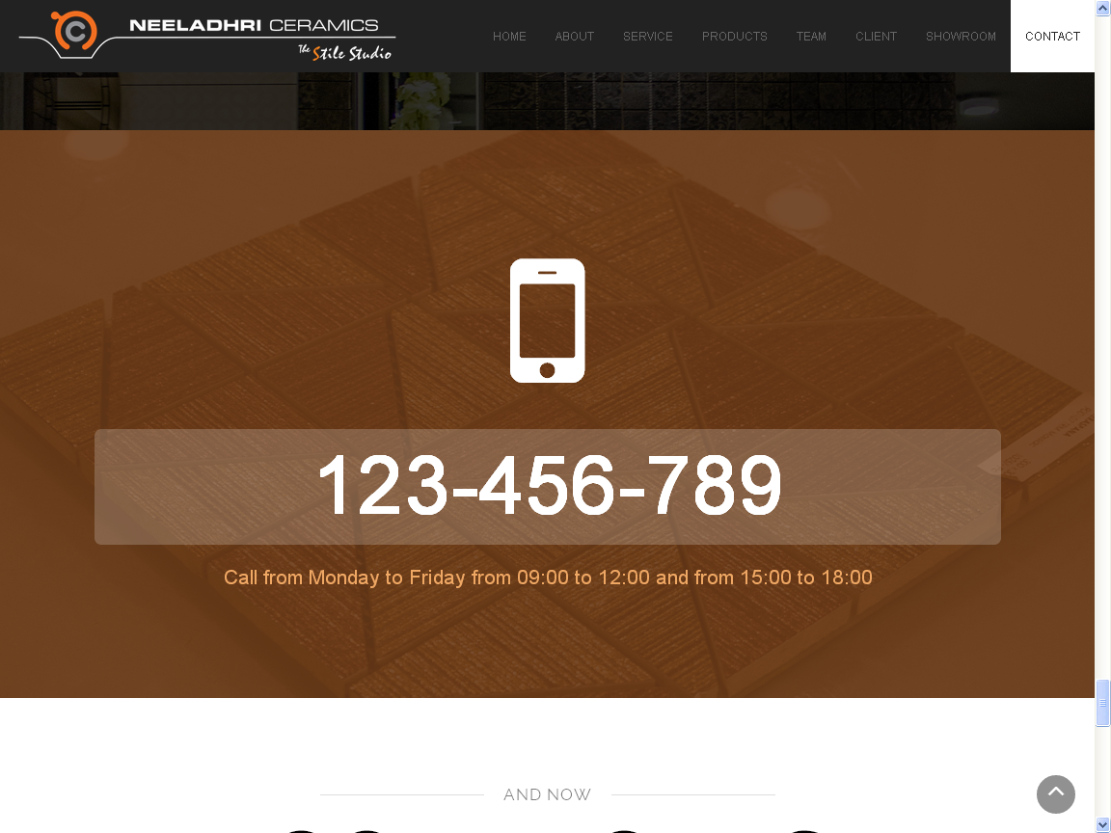

* +91 080 25977578
* Call us Monday to Saturday from 10:00 to 20:00 and Sunday from 10:00 to 14:00

Contact Us 2

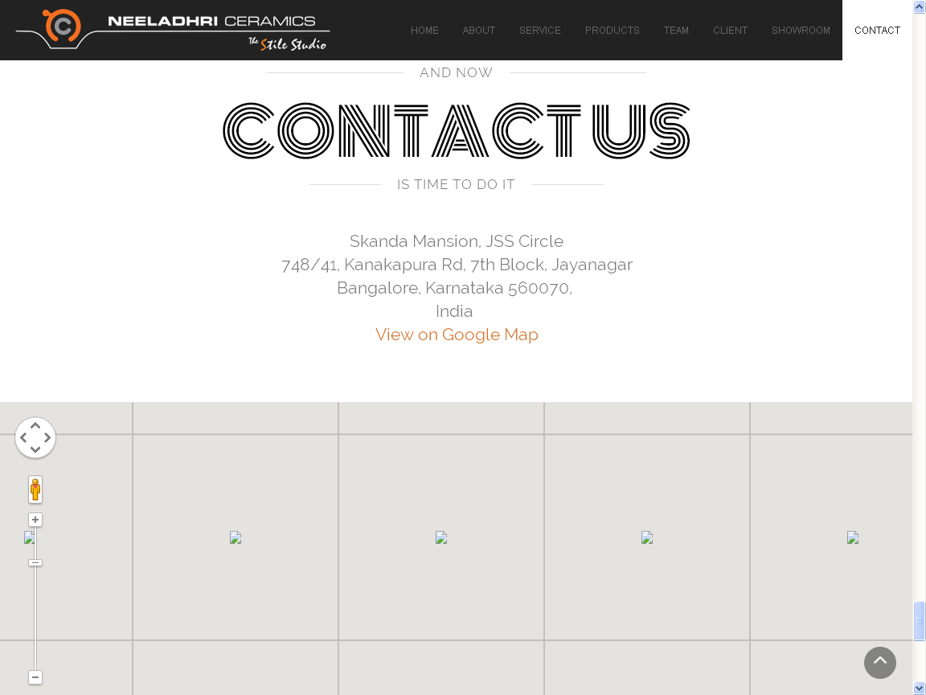

* This map should indicate the route map from the current location of the user to the showroom.
* Kanakapura **ROAD.**

Contact Us 3

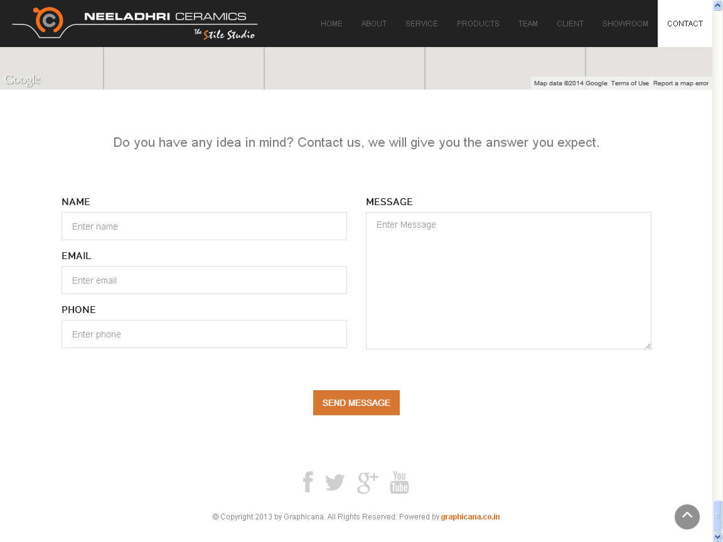

* This part seems to be bland, please make it little more interesting.

Overall Website Changes

* Animations when scrolled up and down should repeat.
* Make sure at any cost the customer should not exit the page, and add on’s should be like the page extension.
* Tab icon should be the company’s logo.
* All waiting signs in the webpage should be company logo with rotating animation or something similar to Windows 8 where the logo of the company is still and few dots moving from left to right at the bottom or something quite unique and different animation along with the company logo..
* Kindly send me the images which were captured, along with the image of the company name and logo without back ground in black letters and logo retaining to the same colour.